ANNUAL REPORT 2012 - 2013

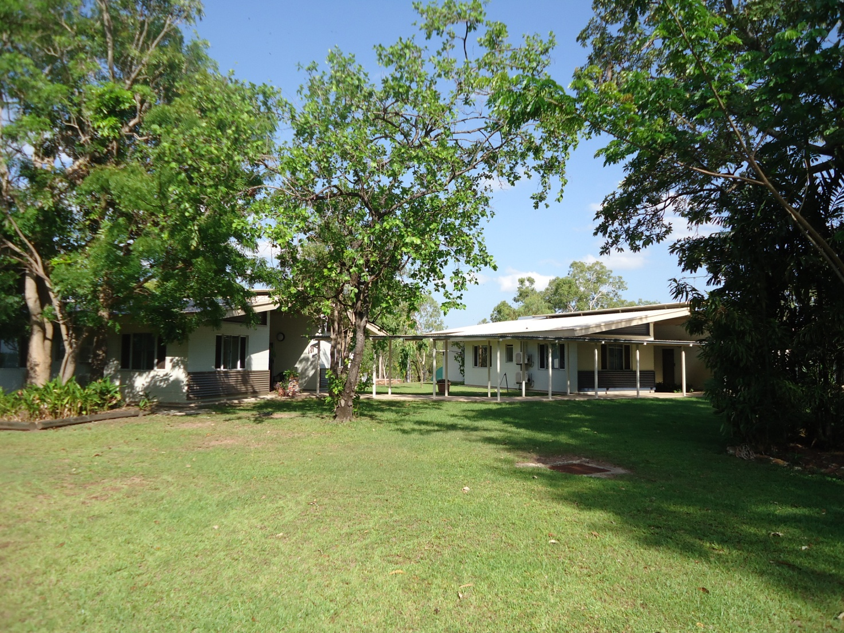

Forster Foundation for Drug Rehabilitation Incorporated

Annual Report 2012 – 2013

Contents

Section

Strategic Plan – Including Mission and Vision........................................................

Who we are and what we do..................................................................................

Members of the Forster Foundation......................................................................

Chairperson’s Report.............................................................................................

Director’s Report...................................................................................................

General Purpose Financial Report 30th June 2013.................................................

Banyan House
A residential therapeutic community
Banyan House is a residential Therapeutic Community located in Darwin, Northern Territory offering a treatment for people recovering from alcohol and drug addictions and any co-occurring mental health disorders.

Vision  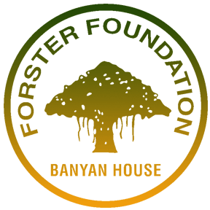  “To lead the way in rehabilitation  developing emotionally strong, healthy  individuals, families and communities free  from the effects of substance misuse.”  Mission  “To understand and reduce the harm to people, families and communities caused by substance misuse and any co-occurring mental health disorders.” | Values  Community - encompassing collaboration, participation and fellowship with others.  Respect - prejudice free consideration of the rights, values and beliefs of all people.  Transparency - openness in relation to the decisions affecting others and any limitations on such decisions.  Self improvement - to be the best we can be.
We provide

Residential rehabilitation program
Residential supported withdrawal program
Alcohol and drug assessments
Courts and Police diversion programs
Outreach services
Post-program follow-up
Education and information capability development

Strategic Directions

Therapeutic program | Quality | External relationships | Corporate
Priorities | Priorities | Priorities | Priorities
Continue with withdrawal and rehabilitation programs and build capacity to extend to special communities, eg corrections | Continue the focus on quality assurance and research to improve the effectiveness of the therapeutic program/s and to demonstrate the relevance and effectiveness of the therapeutic model to stakeholders. In particular this includes:  - Quality accreditation  - Continuing research based on client Inventory and health measures data | As the key influence on sustainability, establish a culture and practice of collaboration and meaningful engagement with funding, collaborative and client stakeholders. | Align service or operational plans and board reporting with outputs and outcomes in the program logic.

Who we are and what we do

Banyan House residential rehabilitation community

Banyan House residential Therapeutic Community provides a safe, secure, alcohol and drug free environment for people to recover from substance dependency. Our approach to treatment is described over the page.

We offer:
- Extended Residential Program
- Aftercare Program
- Co-managed Residential AOD withdrawal
- Family Support
- Drug education and support
- Clinical assessments
- Legal and Court reports
- Pre court diversion program

Parent/s with children under 13, are welcome in the program. We have two family duplexes and include parenting and early childhood development activities into the program for these clients and their children.

Referrals to Banyan House rehabilitation program are welcome.
Simply ring Banyan House on 8942 7400.

Ask to speak to our Intake staff member or any clinical staff member. If Banyan’s program appears a good treatment option for the client, we’ll arrange a comprehensive assessment for acceptance into the program.

The residential rehab program costs $195 per week. This covers accommodation in modern, ensuite units, all meals and rehab program participation. We facilitate clients’ access to Centrelink benefits while in residence and this covers the program fees with the remainder managed in an individual trust account for each client.
Comprehensive information describing Banyan House, services and research projects is available from our website www.banyanhouse.org.au.

The Therapeutic Community approach to alcohol and other drug rehabilitation

Banyan House follows the Therapeutic Community approach with alcohol and other drug rehabilitation treatment. In Therapeutic Communities, client progress and eventually their stable recovery, involves multidimensional changes in terms of lifestyle and personal identity (De Leon, 1995; 2000).
It is a complex perspective of the individual and the recovery process in which treatment must address deficiencies in a range of dimensions to foster global change in the whole person.
These dimensions and illustrations of behaviours are described in the table below:

Domain | Aspect | Examples
Developmental | Maturity  Responsibility  Values | “I regularly meet my obligations and responsibilities”
Socialisation | Lifestyle  Maintains image  Work attitude  Social Skills | “I still have attitudes and behaviours associated with the drug/criminal lifestyle”
Psychological | Cognitive skills  Emotional skills  Self Esteem | ‘I am able to identify my feelings and  express them in an appropriate way”
Community | Program rules  Community engagement  Role model | “I understand and accept the program  rules, philosophy and structure”

TC treatment is conceptualized as a unique social psychological approach, defined as “community as method”— the use of the peer community as a context to facilitate developmental, social, and psychological change in individuals. The context consists of all program activities (e.g., groups, meetings, privileges, sanctions, work, seminars and workshops) and relationships with peers and staff. These are viewed as interventions designed to produce cognitive, behavioural, and attitudinal change.

The “method” also consists of the community’s expectations, assessments, and responses concerning the individual’s participation in the roles and activities of the daily regimen. Maximum change occurs through the individual’s total participation (“immersion”) in all program activities and social roles. The extent, quality, and consistency of client participation in all activities are viewed as a critical fourth dimension of client progress in treatment. Change in this community membership dimension is needed for changes to occur along the other three dimensions.

Members of the Forster Foundation

Professor Robert Parker Chairperson robert.parker@nt.gov.au

Nicola Coalter Vice-Chairperson nicola@amity.org.au

Gerry West Board Member gerry@banyanhouse.org.au

Jackie Antoun Secretary jackie.antoun@nt.gov.au
(Resigned 24/9/13)

Madhur Evans Public Officer madhur@banyanhouse.org.au

Tracey Hehir Treasurer t.hehir@darwin.nt.gov.au
(Resigned 4/10/13)

Chairperson’s Report

The year has been a very busy time for the Foundation.
The Foundation was busy keeping informed of NT Government initiatives, such as the new alcohol legislation and what this may mean for the Foundation.

The Health Minister, Robyn Lambley also toured Banyan House at the invitation of the CEO and Board. This followed an initiative from one of the senior clinicians, Neil, who proposes writing to the government to see if the Foundation could expand on some of its services, such as developing the therapeutic community programs in other locations, such as prisons.
The Forster Foundation has been undergoing accreditation as an NGO service provider this year. The Foundation has also had the good fortune to obtain the services of an outside expert, Meridy Calnin for 6 months to review its current programs and opportunities for improvements.
The Board welcomed Melissa Heywood this year and she has been a significant support to the Board. Gerry has also led the process for developing the Vision Statement for the Board and Foundation which is very welcome. The Board also noted the retirement of Tracey Hehir (Treasurer) and Jackie Antoun. Both individuals have made a significant contribution to the work of the Board and we wish them well in their future endeavors.

The Board wishes to thank all the executive officers and staff of the Foundation, for their hard work in often stressful environments through the year and the Board looks forward to supporting them in challenges for 2014.

Best Wishes

A/Prof Rob Parker
Board Chair
Forster Foundation

Directors Report

This year saw the end of our 2010 – 2013 Strategic Plan which was focused on Consolidation, Evaluation and Profile. Consolidation was considered to be Banyans capital, capability and systems development and improved to match the new facility. Evaluation of Banyans rehabilitation program using the Client Inventory Assessments and Profile was to recognise Banyan House as a premier Darwin based AOD rehabilitation facility. Banyan House staff were successful in achieving these objectives by increasing our funding over the 3 years by $400,000. We continued to use the Client Inventory Assessments, and Richard Chennell presented a report on his findings at the ATCA conference. Very similar research is being conducted in NSW rehabilitation facilities which yielded very similar results to Banyan House, which means even though we are a small isolated rehab we still provide, effective treatment. We have provided many in-house presentations to other stake holders and service providers as well as participating in activities such as Drug Action Week in an effort to raise Banyan Houses public profile.

The process of creating the new 2013 to 2016 strategic plan was put into action with the members of the Board meeting in February to initiate the process. The first priority was to look into our Constitution and interpret its objectives to ensure the upcoming plan aligned with the constitution. Once the interpretations were established the board mapped out some strategies on how to achieve these objectives. A meeting was organised with Banyan House senior staff and the Board to further develop the plan incorporating input from all Banyan House staff. Once the strategic plan was finalised Banyan House management set about developing the first year’s operational plan, this was presented to the board for endorsement and is now being integrated into the system and Banyan House staff are striving to achieve its goals.

At the beginning of the year, Banyan House’s property lease came up for renewal. In 2003 we were given a 10 year Crown Lease Term over the property and consequentially time was starting to run out.
The lease agreement we had then stipulated that we had to spend at least $800,000 developing the property. That lease expired on the 17th of January this year so we applied for a conversion to a Crown lease in Perpetuity and subsequently we were granted Crown Lease Perpetual no. 2434.

The Therapeutic Community model places a large emphasis on work groups not only from the perspective of a therapeutic tool to develop work ethics, self esteem and pride in our resident body but to improve program effectiveness. One full day per week and several part days are dedicated to property maintenance and development, and because we do much of our own maintenance, servicing and repairs to various pieces of equipment, it became necessary to have a suitable place to do this as Banyan has never had a suitable workshop to carry out maintenance.

Over the years residents were carrying out work on these items wherever they could which often meant under the veranda adjoining a walkway, proving to be not only difficult but unsafe. So this year our Corporate Support Manager secured the funds and we were lucky enough to be in a position to shop around for a new workshop/shed. After obtaining 3 quotes from local builders we settled on the best value for money design and purchased our new workshop. Since then we have been slowly building a lock up section inside the shed for expensive equipment and potentially volatile substances, fuel, glues, paints etc. It has been fitted out with benches so now the residents can do their work in a purpose built safe environment.

Our new volley ball court is half way to completion, there has been a delay in this project as we often rely on what skill set is available within the resident body. Unfortunately we haven’t had a welder in house for some time but things are looking up because we have an apprentice mechanic with us who is a competent welder so I believe it will only be a matter of time before we have ourselves a fence around our volley ball court.

The resident body have also completed the outdoor leisure area; it was originally part of the old veranda. The residents extended and widened the area and finally concreted the floor. It is now a very nice open area to socialise and relax.

The new Enterprise Bargaining Agreement process that commenced last year had its final processes implemented with the employee’s declaration in support of application for approval, signed and sent off to Fair Work Australia, in turn it passed the scrutiny of the Commissioner. The Agreement has been implemented into our system.

Accreditation Process
This financial year Banyan House has been working on the ISO 9001:2008 Quality Management Systems accreditation, as expected it has turned out to involve a lot of work for all staff. The Stage 1 audit was completed in June and a Stage 1 Corrective Action Plan has been made to address the major and minor non-conformities that were found.

The Stage 2 audit was scheduled for October 24th this year, which we thought would give Banyan House time to implement the Stage 1 Corrective Action Plan and provide further training to staff to ensure compliance and build a lasting culture. Due to unforeseen circumstances the Stage 2 audit has been rescheduled for February 2014. This new timeframe still puts us well within the required deadline of June 2014.

Below are some statistics of the various programs we run:

Assessments

# Assessment Episodes |  |  | 108
Males | 82 | Females | 26
# Accepted |  |  | 67

Residential Rehabilitation

# Rehab Episodes |  |  | 70
Males | 53 | Females | 17
I | NI | I | NI
16 | 37 | 5 | 12
Average days stayed |  |  | 90
Shortest |  | Longest
1 |  | 404

At the end of this reporting period June 2013, 7 clients were still in treatment.
5 male clients had completed the program
11 clients (3 females and 8 males) ceased to participate due to mutual agreement

Parents & Children

Total | 9 | Male | 5 – all  part-time | Female | 4 – 1 full-time /  3 part-time

Aftercare

- 2 clients have used the aftercare facilities. 1 female and her 2 children and 1 male.
- 5 clients have accessed Banyan House aftercare services as an outpatient. 4 males and 1 female.

Residential Withdrawal
There were a total of 42 episodes for the Supported Withdrawal Program during this 12 month reporting period.
30 males and 12 females
32 episodes were non-indigenous, 10 episodes were indigenous

Reason for cessation of treatment

 | Frequency | Percentage
Treatment completed | 32 | 76%
Ceased to participate against advice | 9 | 21%
Ceased to participate without notice | 1 | 2%

Principle drug of concern

 | Frequency | Percent
Alcohol | 28 | 67%
Amphetamines | 4 | 10%
Cannabis | 9 | 21%
Morphine | 1 | 2%
Total | 42 | 100%

Northern Territory Illicit Drugs pre Court Diversion Program (NTIDPCDP)

This program isn’t specifically designed for youth or necessarily for counselling treatment but these clients are generally between 12 and 16 years of age and are usually caught with a small amount of cannabis at school or in a public place such as a shopping centre. It is up to the arresting officer’s discretion as to whether or not a client is put through this diversionary programme.
The police have stated Banyan House is the preferred agency as for this diversion due to being responsive, efficient and professional.

18 NTIDPCDP clients were seen in this financial period

The House participated in two camping trips this year, the first trip was to Gunlom Falls which is in Kakadu national park and more recently went on their annual camping trip to Litchfield National Park. The trip was a 5 day event and was a huge success. The residents worked well together to plan and organise the trip and it was a great opportunity to use some of their new skills and insight in a challenging environment. These types of activities provide staff and the residents with insight into behavioural patterns that may not be as evident in a controlled structured environment such as Banyan House. These behaviours are then addressed in therapy groups once the house returns to Banyan.

I would like to take the opportunity to thank the Banyan Board of Management for their hard work throughout the year, these positions are purely voluntary and take much of your valuable time, if it wasn’t for your generosity in regards to your time and effort organisations like Banyan House would find it hard to operate. I would also like to thank the staff at Banyan House who have also worked tirelessly throughout the year and have given their all to make Banyan House what it is today.

Regards

Kelvin Dargan
Director
Banyan House for Drug Rehabilitation
PH: (08) 8942 7400
director@banyanhouse.org.au

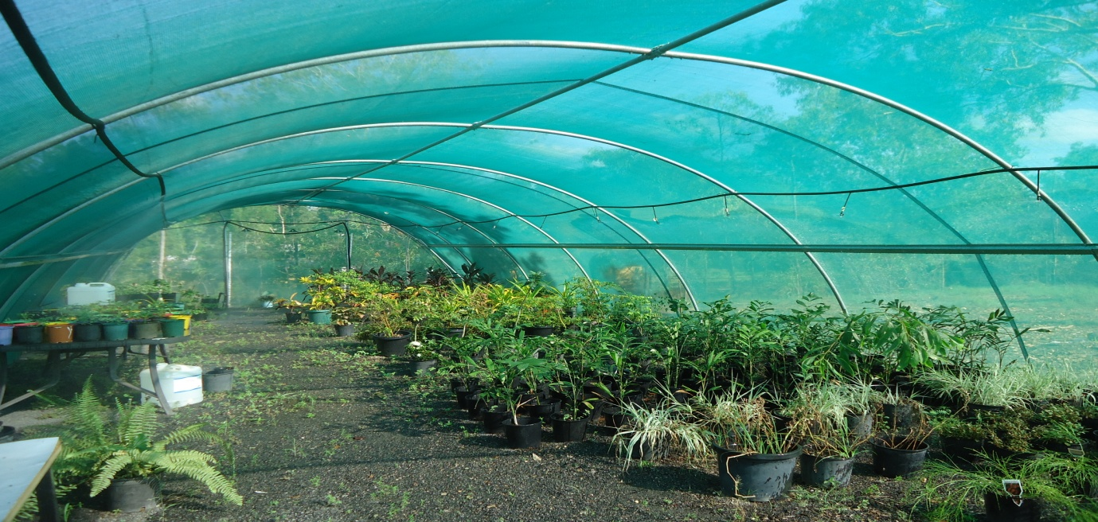
Above: Banyan’s Greenhouse.

Below: Newly built workshop/shed.

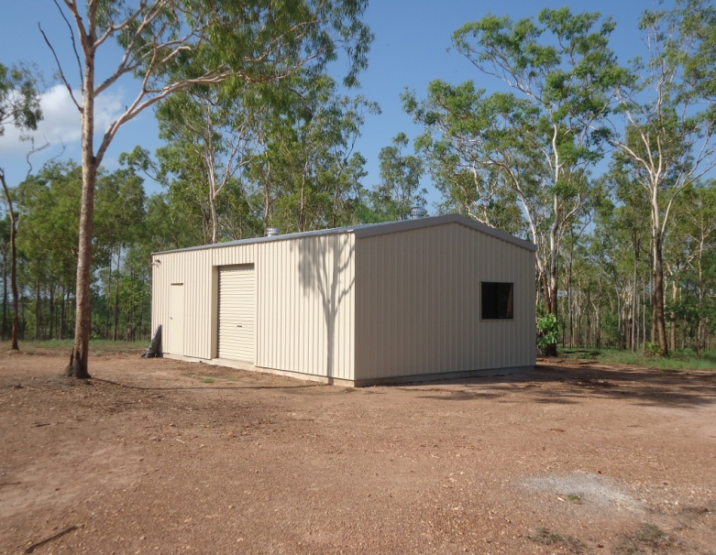
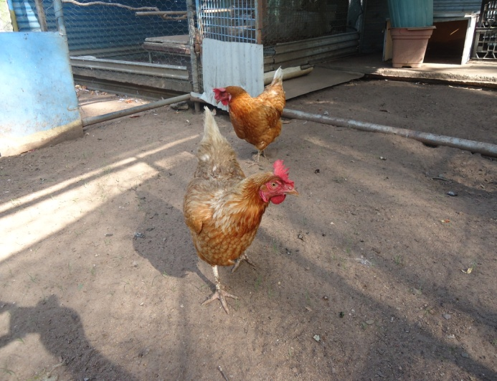Above: Pet chickens.

Below: Communal / visiting area. Below: Tranquillity garden / pond.
